|  |  |  |  |  |  |
| --- | --- | --- | --- | --- | --- |
| **PAF-Karachi Institute of Economics & Technology**  **(The Center of Excellence)**  **College of Computing and Information Sciences**  **Software Engineering Course Project Proposal Form** | | | | | |
| ***Sno.*** | ***Stud. ID*** | ***Names*** | ***Course Name/CID*** |
| 1 | 8476 | Tayyab Mehmood | **Software**  **Engineering**  **(106269)** |
| 2 | 9017 | Syed usman Ali |
| 3 | 9131 | Haris Ahmed Khab |
| 4 | 8495 | Nabeel Rao |
| 5 | 8763 | Mohammad Imran Khan |  |

**Project Title:**_ [ Same OOAD PROJECT NAME now must have 5 CRUD based

FEATURES] _

1. **Motivation:**

*The main* ***objective*** *of Learning Management Systems is to enhance the learning process.*

1. **Functional Features**

*Specify the features of your project which would make it significant for the evaluators.*

* 1. *New Student, Teacher , Admin registration.*
  2. *Admin can view all details of faculity and students.*
  3. *Admin can delete any student or faculty.*
  4. *Admin can update data of student and faculty.*
  5. *Student can select courses.*
  6. *Teacher can view students who are registered in classs.*
  7. *Student can enroll course.*
  8. *Admin can enroll or delete course.*
  9. *Teacher can add assignment.*
  10. *Student can view assignments*

*SDLC PHASES*

* + *Requirement Gathering* • *Planning.*
  + *Analysis*
  + *Desgin*
  + *Testing*
  + *Implementation*
  + *Review*

* + 1. *Module 1: Login Authentication (Common for all members)*
    2. *Module 2: Admin*
    3. *Module 3: Faculty*
    4. *Module 4: Student*
    5. *Module 5: Course Registration*
    6. *Module 6: Faculty CID Registration*

1. *Expected Detail of all Modules to be covered by each Member* **Member 1: Login + Module 2** 
   * 1. **Demonstration of Create actitivty on Admin**
     2. **Demonstration of Review actitivty on Admin**
     3. **Demonstration of Update actitivty on Admin**
     4. **Demonstration of Delete actitivty on Admin**
     5. **Demonstration of Search actitivty on Admin**

**Member 2: Login + Module 3**

* + 1. **Demonstration of Create actitivty on Facuilty**
    2. **Demonstration of Review actitivty on Facuilty**
    3. **Demonstration of Update actitivty on Facuilty**
    4. **Demonstration of Delete actitivty on Facuilty**
    5. **Demonstration of Search actitivty on Facuilty**

**Member 3: Login + Module 4**

* + 1. **Demonstration of Create actitivty on Student**
    2. **Demonstration of Review actitivty on Student**
    3. **Demonstration of Update actitivty on Student**
    4. **Demonstration of Delete actitivty on Student**
    5. **Demonstration of Search actitivty on Student**

**Member 4: Login + Module 5**

* + 1. **Demonstration of Create actitivty on Course Registration**
    2. **Demonstration of Review actitivty on Course Registration**
    3. **Demonstration of Update actitivty on Course Registration**
    4. **Demonstration of Delete actitivty on Course Registration**
    5. **Demonstration of Search actitivty on Course Registration**

**Member 5: Login + Module 6**

* + 1. **Demonstration of Create actitivty on Facuilty CID Registration**
    2. **Demonstration of Review actitivty on Facuilty CID Registration**
    3. **Demonstration of Update actitivty on Facuilty CID Registration**
    4. **Demonstration of Delete actitivty on Facuilty CID Registration**
    5. **Demonstration of Search actitivty on Facuilty CID Registration**

**Project Planning**

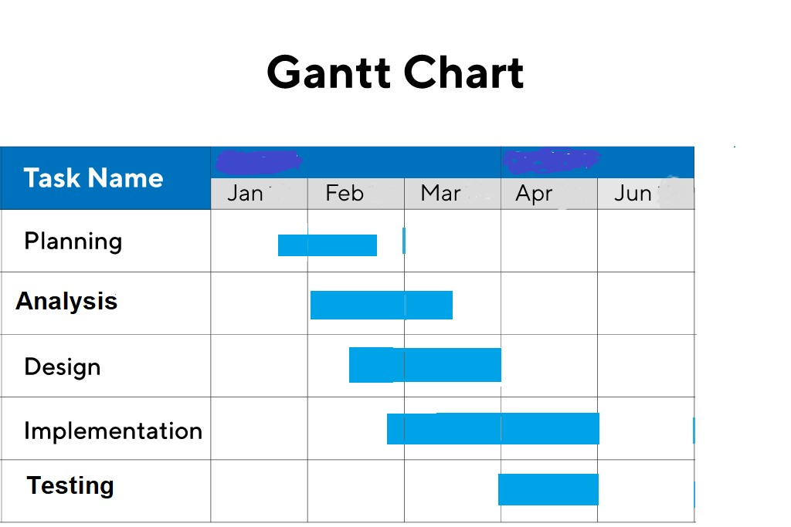

1. 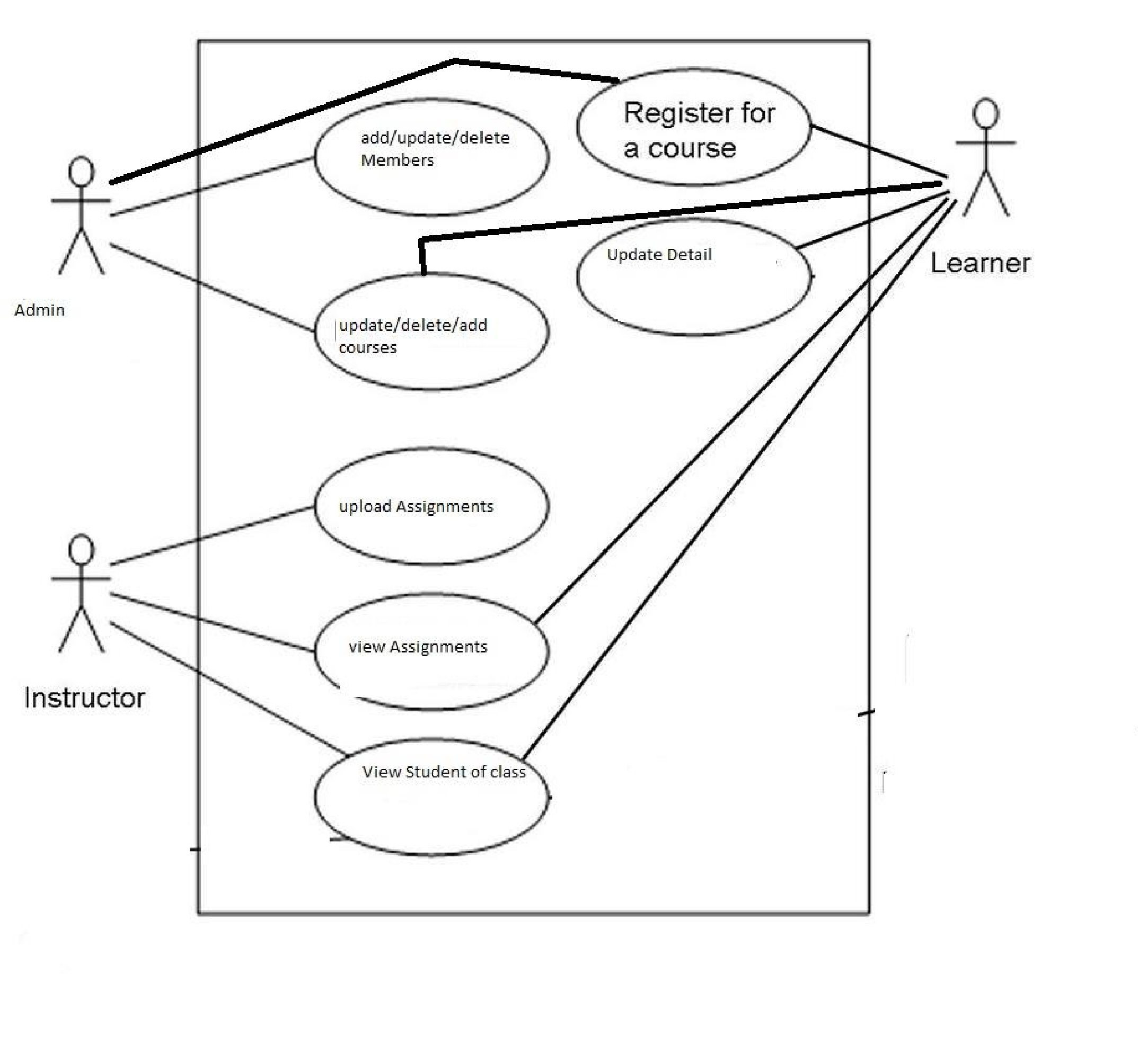**Diagrammatic Representation of the Overall System**

Student’s Signature: Haris Ahmed Date: 27 January/2020_